**Smart Street Light Monitoring System**

Project Description:

Streetlights are among a city’s strategic assets providing safe roads, inviting public areas, and enhanced security in homes, businesses, and city centres. They’re usually very costly to operate and they use in average 40% of a city’s electricity spending. it’s becoming crucial that municipalities, highway companies and other streetlight owners deploy control systems to dim the lights to the right light level at the right time, to automatically identify lamp and electrical failures and enable real time control.

Based on the intensity levels we can change the intensity of the street lights from the User interface which is created in Node Red platform of IBM Watson services. We can even control all the street lights from that User interface.

Highlights of the Project:

* Working with IBM Watson cloud services.
* Accessing Sensor data from anywhere in the world.
* Realtime light intensity values are triggered based on sensor values automatically to the app developed.
* Individual and Area wise Street lights can be controlled using a single app.
* If necessary, the required street lights can even be made dimmer using the mobile app.
* Reduces Manual effort in controlling the street lights.

# Hardware:

* Node MCU
* LDR
* LED

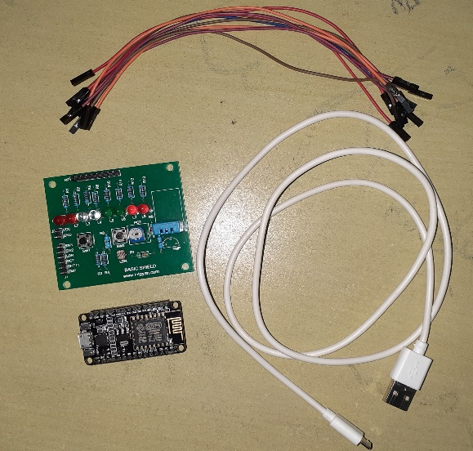

# Softwares:

* Arduino IDE
* MIT A2 App companion
* IBM Watson Cloud Services

Procedure to connect the components:

1. Connect the Vcc and GND pins of the node MCU to the Vin and GND of Basic component sheat.

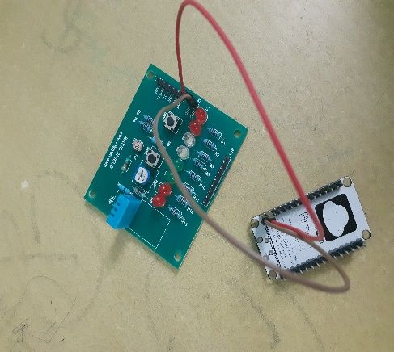

1. Now, connect the LDR output to the A0 (analoginput) of the node MCU.
2. Finally declare some output pin in node MCU say, D5 here, and connect it to an LED.

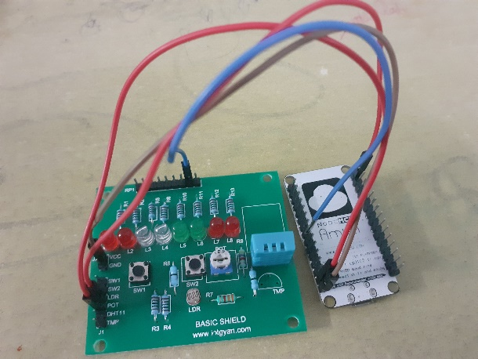

1. After making these connections successfully, power the node MCU with USB cable.

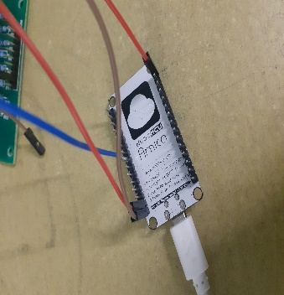

Node-Red Connections in the IBM cloud services:

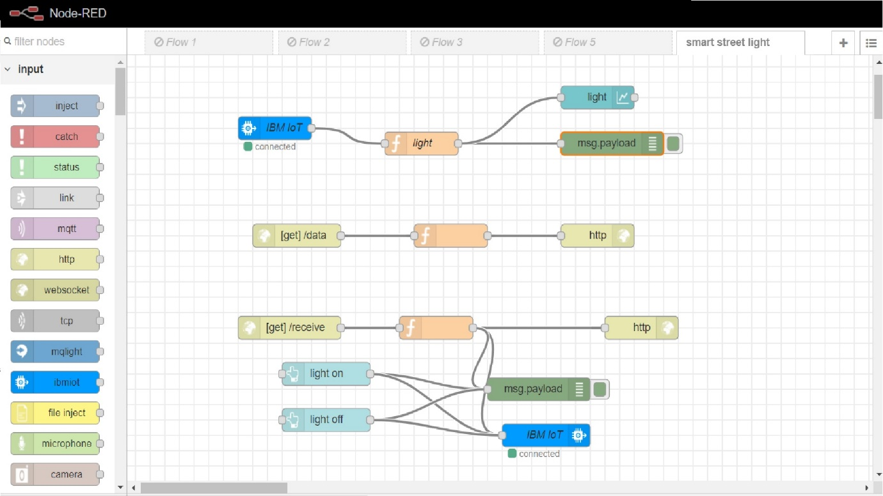

MIT A2 app companion interface and block conections:

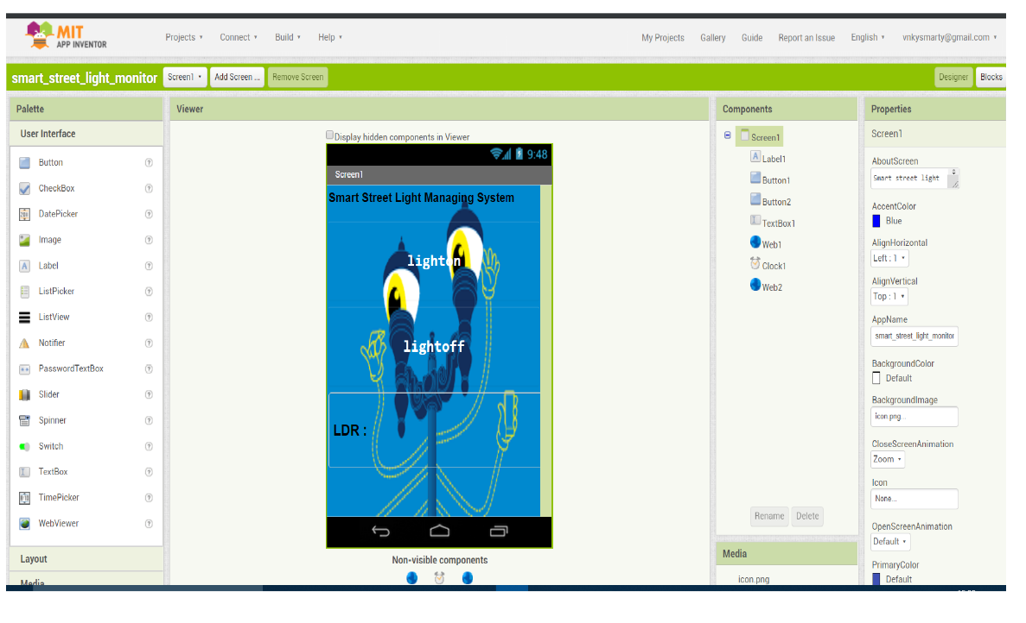

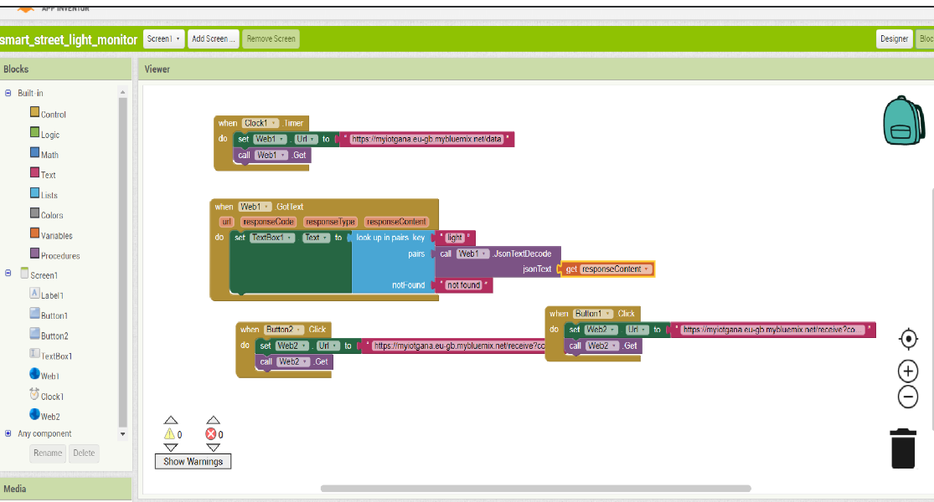

Collect the code from the link below and dump the code in node MCU:

<https://github.com/Gana1122/IoT/blob/master/Smart_Street__light_monitoring_system/Smart_Street__light_monitoring_system.ino>